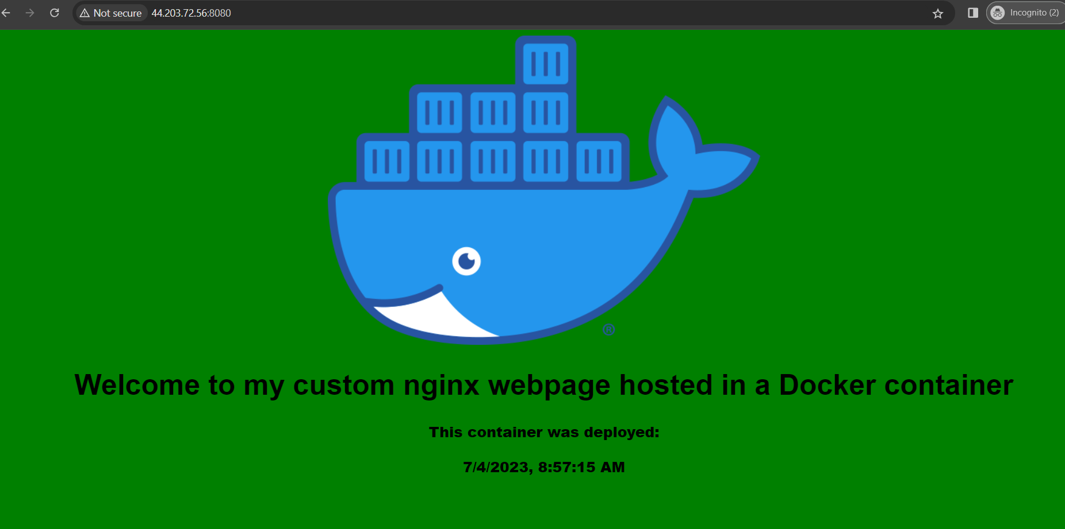

Docker file:

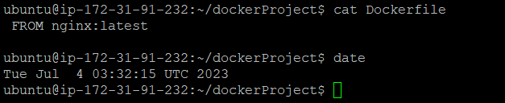

Docker compose file:

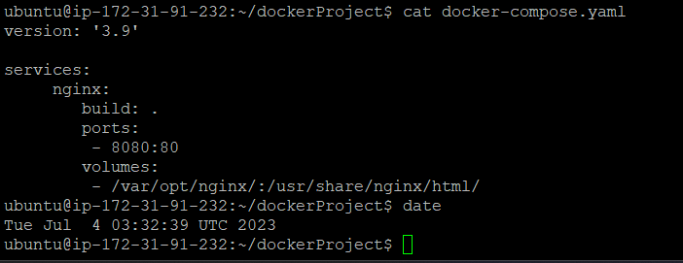

Volume:

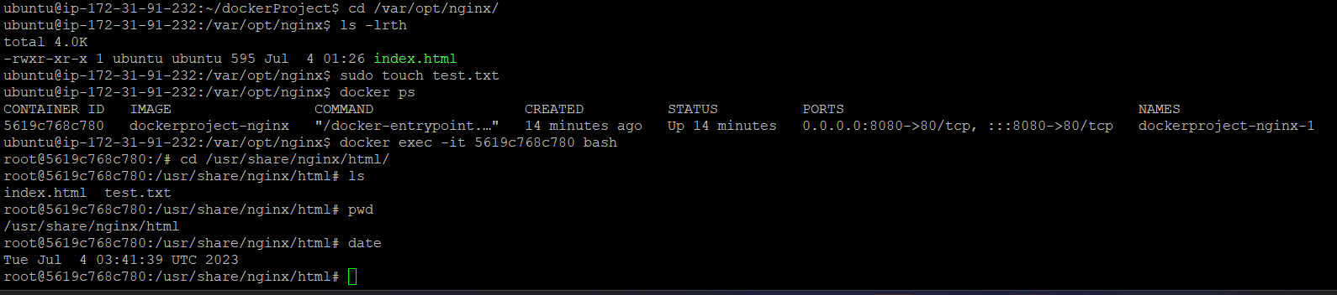

Docker Push:

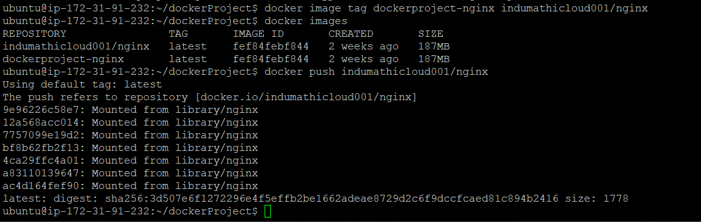

DockerHub:

